Group members:

Muhammad Izham Bin Norhamadi B032020039

Affendy Elyas bin Azhari Sharidan B032020024

Ahmad Sha Herizam Bin Tahir B032020009

# Lab 4 Integrating Input Device using GPIO

## Steps during hands on.

1. Attach 3 LED using Male-Female jumper wires on Breadboard and connect with GPIO 18, GPIO 14 and GPIO 15.
2. Attach to negative at breadboard with ground using the jumper wire.
3. Create new Python File to make LED connected with GPIO 18, GPIO 14 and GPIO 15 blinking in order.
4. Run the Phyton code

## GPIO – LED connection design

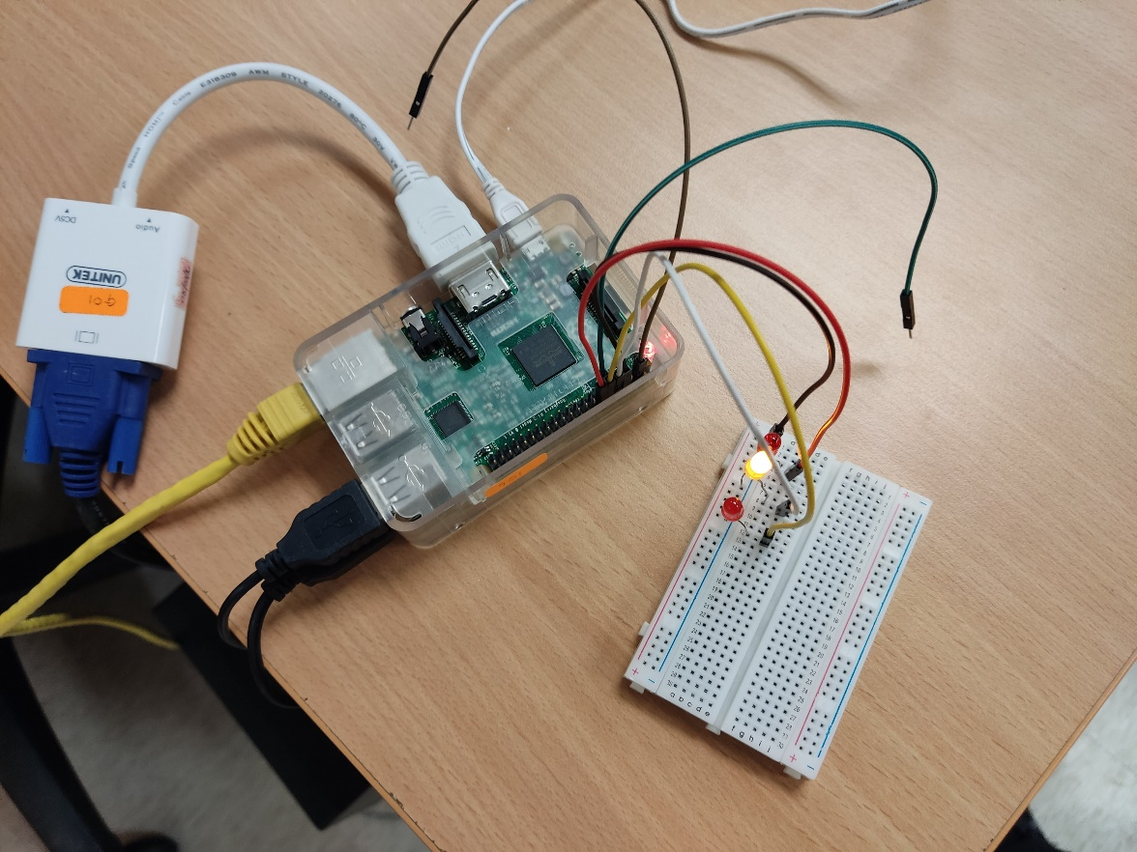

## Python Code with explanation

